Pearl Ayem - 34404160

**ATSC 303 Lab 5 – Barometry**

The following equations were used for the gravity correction and sea level reduction:

For gravity correction:  
We assume the index error, i = 0 assuming the barometer was checked and calibrated before the lab, and no contamination occurred during the lab.

The mean height within 150km was estimated at 5.182 m, as per the geoid height from the EGM96 model. This was deduced from the following calculations:  
Geoid Height Results:

* source: https://www.unavco.org/software/geodetic-utilities/geoid-height-calculator/geoid-height
* Latitude: 49.2606° N = 49° 15' 38.16" N
* Longitude: 123.246° E = 123° 14' 45.6" E
* GPS ellipsoidal height: 105 (meters)
* Geoid height: 5.182 (meters)

The 105m height ASL for UBC is assumed as per the calibration of the Kestrels.

As for the temperature correction , I assumed this to be 0 as well because the Eco-Celli was not filled with mercury, while all of the corrections are with mercury as a function of temperature. These temperature effects must be compensated, which they were by the initial calibration between the pressure and temperature.

For the sea level reduction, the current temperature was taken from the davis_wxstation dataset and averaged between 11am to 1 pm to average during the measurement period (on Feb 7th). The average temperature came to 4.533°C and RH was averaged to 97.111%. The temperature 12 hours ago was averaged between 11pm the previous day (Feb 6th) until 1am on Feb 7th. The average temperature came to 3.389°C and RH was averaged to 97%. The station height is set to 105m for UBC, and station pressure was measured from the sensors.

The plots generated for the data, are given on the following page. It can be seen that the only significant difference before and after correction is in the data derived with the Eco-Celli barometer. Both the plots showed that each sensor except the YVR one followed the same trend – they increased for the first 2 readings and decreased afterwards. There was no outlying data in terms of the 6 plot lines, and the barometers were reading different pressures due to their different mechanisms.

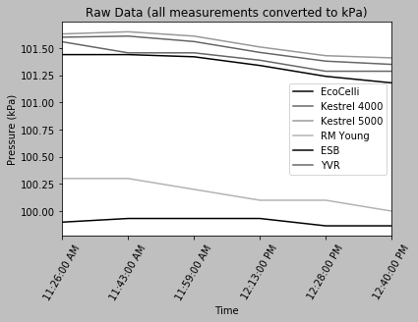

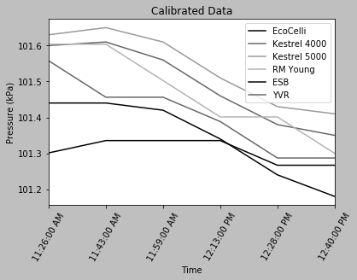

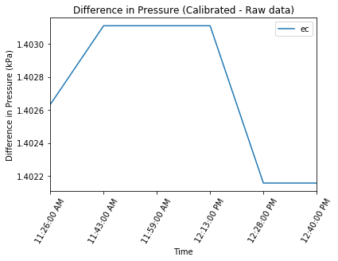

**Further Questions**

1. What was the value of the gravity correction(s)? Did it make a difference when compared to the sensor’s significant figures?

The value of g came up to 9.816726239931887 ms-2. It did not affect the sensor’s significant figures because they are less than that of g, and therefore will remain as is even after the reductions.

1. What was the value of the sea-level reduction? Did it make a difference when compared to the sensor’s significant figures?

The sea-level reduction value is 1.0129465445005967 which is also more than the sensor’s significant figures. Therefore, this would not affect the sensor.

1. Which barometer do you think is the most accurate and why?

The spec sheet for the Kestrel 4000 and Kestrel 5500 both state an accuracy of ±2.4 hPa in the barometric pressure measure. The spec sheet on the RM Young gave an accuracy of ± 2hPa for barometric pressure measurement. In general I’d think these are more accurate because they are all capacitance-based sensors. However, after corrections and the assumptions made during the correction it is harder to stay if the accuracy stays. And hence I would think the sensor at YVR is most accurate to the true value of sea level pressure.

1. Which barometer do you think has the highest resolution and why?

The YVR or the Eco-Celli thermometers have the highest resolution since they can report upto 2 decimal places. In both cases they might lack precision, and this resolution depends on the user, however the scale on the Eco-Celli was engraved for every inch, and therefore the reading can be reported for upto 2 decimal places.

1. Which barometer do you think is the least accurate and why? For that barometer what is the bias value?

I would think the least accurate is the Eco-Celli because the reading depends on the way the user reads the barometer, and on top of that it goes through several corrections which make assumptions about the state of the atmosphere. The largest bias in this case would be human perception, followed by the assumptions made during the correction.

1. Which barometer do you think has the lowest resolution and why?

Out of the Kestrels, ESB and RM Young, I’d say the ESB had the lowest resolution since it was very slow to respond as compared to the other values, and did not change for small fluctuations. It still reported to 1 decimal place, but this value changed very slowly.

1. When you adjust your pressure reading to sea level, e.g. with the RM Young 61205V and the Eco-celli, why is your answer probably different than the sea level pressure reported at YVR airport? (hint: think about the equation(s) used, any assumptions we are making, and weather conditions)

The sea-level reduction made some assumption about the station height being at 105m and an isothermal atmosphere that let us use equation 7.7 (Harrison chap.7) to find the sea level correction. Another assumption was about which temperature to use for the reduction – I ended up using the average during the time period of the measurement in order to calculate a virtual temperature.

1. For what situations is gravity correction important for pressure measurements, and for what situations is it not? (Short answer, in your own words)

The gravity correction is important in areas of high altitude, where the average altitude of the surrounding does not match that of the station.

1. Calculate (on a spreadsheet) and plot the variation of sea-level gravitational acceleration with latitude. (Hint, use eq. 3.A.6 from WMO-8 chapter 3, annex 3. A)

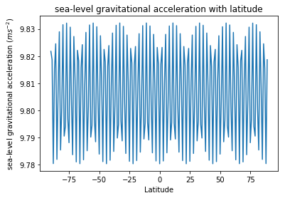

1. For the latitude of UBC, plot local gravitational acceleration g vs elevation H above sea level for (a) over land having terrain elevation of 500 m; /2 (b) over the ocean of depth 1 km; and /2 (c) at a shoreline at a 50% mix of land from (a) and ocean from (b). /2 (Hint, use slide 30 and eqs. 3.A.7-9 from WMO-8 chapter 3, Annex 3.A)

Assumptions: The mean depth of the Strait of Georgia is 157 (source: https://en.wikipedia.org/wiki/Strait_of_Georgia)

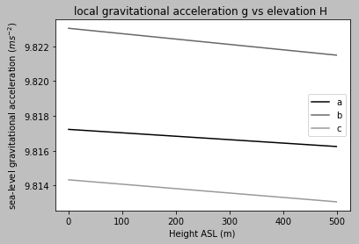

1. Compare (discuss, plot using a spreadsheet) the equations for pressure reduction to sea level for the WMO equations in WMO-8 Chapter 3, vs. the reduction equation from Stull’s textbook (as presented in Lecture, and in the lecture notes online; see slide 54)

To carry out the sea level reduction using the WMO guidelines I needed these additional formulas.

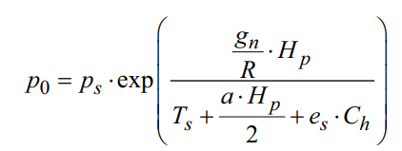

It was noticed that the difference in the calibrated pressure from the two methods is very small. Stull’s method gave a reduction of 1.012999745599563 and the WMO method gave a reduction of 1.0129858376580465. The difference between the two is 1.39e-05. The plot of this difference is given below. They are so similar in nature likely because virtual temperature also accounts for a lapse rate, just assume isothermal temperature profile and the saturation pressure uses the same temperature as Stull’s method.

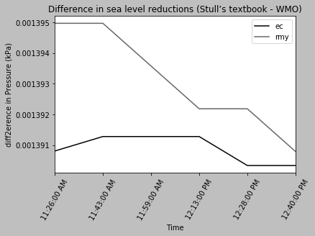

1. With respect to the mercury barometer, how much inaccuracy can we tolerate in the measurement of temperature if we want the pressure error ≤ 0.05 hPa? Assume the pressure is 960 hPa.
2. Name three corrections commonly used with a mercury barometer.
   1. Index correction
   2. Gravitational correction
   3. Temperature correction
3. Calculate the static sensitivity of a mercury barometer. How could you increase the static sensitivity of a mercury barometer?

The transfer equation is . To increase the sensitivity of a barometer it would be necessary to find another barometric fluid with the desirable properties of mercury but with less density.

1. What is the dynamic wind error when the wind speed is 20 m s-1? Why do we need to take temperature into account when calculating the dynamic wind error for very high wind speeds?

The equation of dynamic error is: were Δp is the error, C is the coefficient,ρ is air density and V is wind speed. Assuming C = 0.2, the dynamic error is 40Pa. For high wind speeds, the temperature is often lower than the measured temperature and thus we need to take it into account.

1. What is the raw output for the following sensors: a mercury barometer, and an aneroid barometer?
   1. Mercury barometer: raw output is height
   2. Aneroid barometer: raw output is the deflection of the diaphragm center
2. Why have aneroid barometers tended to replace mercury barometers?

Mercury is toxic, has a high thermal expansion so needs temperature corrections, it’s not easily portable for fieldwork, and contamination can cause changes in the surface tension of the mercury, and hence the reading overall. Even with newer versions it is hard to automate a reading and get rid of the biases associated with getting a reading.